PRICE SCHEDULE
LOT 1 | DESCRIPTION | QTY | UNIT PRICE GH¢ | Total Price GH¢ | Total inland price GH¢ | TOTAL  CIP GH¢ | Incidental Ser. GH¢ | Total Tender Price GH¢ | Remark
 | 2 | 4 | 5 | 6 | 7 | 8 | 9 | 10 | 11
 | VACCINE REFRIGERATOR | 5 | 92,000.00 | 460,000.00 | NIL | 460,000.00 | NIL | 460,000.00 | NIL
SUB-TOTAL GHS |  |  |  |  |  |  |  | 460,000.00
4% VAT GHS |  |  |  |  |  |  |  | 18,400.00
GRAND TOTAL GHS |  |  |  |  |  |  |  | 478,400.00

TOTAL AMOUNT: FOUR HUNDRED AND SEVENTY-EIGHT THOUSAND, FOUR HUNDRED GHANA CEDIS ONLY
DELIVERY: WITHIN 5 WEEKS AFTER ORDER CONFIRMATION
PAYMENT: WITHIN 90 DAYS AFTER DELIVERY
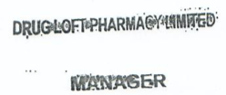
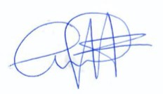
VALIDITY: 90 DAYS
WARRANTY: 24 MONTHS

SIGNATURE: …………………………………

